ArrayList

- Dynamic array (java.util.ArrayList)

- Syntax: ArrayList<Integer> list = new ArrayList<>();

- Methods: add(), get(), set(), remove(), size()

A resizable array implementation of the List interface.

Stored as a contiguous block of memory.

Good for index-based access and appending elements.

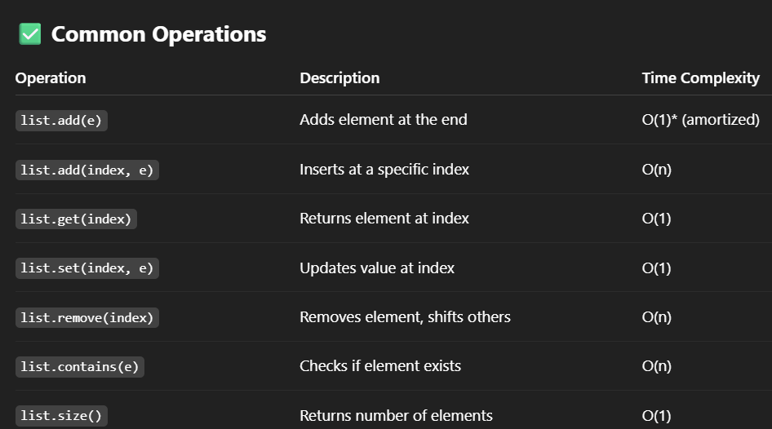

\*Amortized O(1): occasional resizing makes it more than O(1) in rare cases.

HashMap

map.put(K, V) 🡪 Add or update a key-value pair   
map.get(K) 🡪 Returns value for key K, or null if absent   
map.containsKey(K) 🡪 Returns true if key K exists   
map.containsValue(V) 🡪 Returns true if value V exists   
map.remove(K) 🡪 Removes the key-value pair for key K

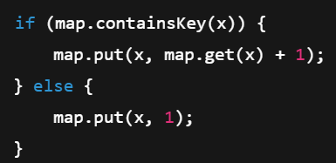



map.getOrDefault(x, 0)

* Tries to get the value for key x.
* If x is not in the map, it returns 0 (default value).

HashSet

A collection of unique elements

No duplicates allowed

Mostly used for fast lookups, duplicate removal, and membership checks



